What is the domain of a function? | The set of values that are allowed to be the input
What is the range of a function? | The set of values of all possible outputs

Things in:
[-] are the guidance section from the specification
#-# are from the content exemplification for enhanced content guidance (not from specification from another document belong to edexcel)

AS LEVEL

1 Proof

1.1 Understand and use the structure of mathematical proof, proceeding from given assumptions through a series of logical steps to a conclusion; use methods of proof, including: Proof by deduction, Proof by exhaustion, Disproof by counter example [ Examples of proofs:

Proof by deduction e.g. using completion of the square, prove that n2 − 6n + 10 is positive for all values of n or, for example, differentiation from first principles for small positive integer powers of x. This is the most commonly used method of proof throughout this specification.

Proof by exhaustion: Given that p is a prime number such that 3 < p < 25, prove by exhaustion, that (p – 1)(p + 1) is a multiple of 12.

Disproof by counter example e.g. show that the statement “n2 – n + 1 is a prime number for all values of n” is untrue.
#Candidates may have to choose the most appropriate method of tackling the proof#
What is a theorem? | A statement that has been proven
What is a conjecture? | A statement that is yet to be proven
What is the symbol for natural numbers? | ℕ
What is the symbol for integers? | ℤ
What is the symbol for quotients/rational numbers? | ℚ
What is the symbol for real numbers? | ℝ
TAKE THIS PROOF ADVICE TO HEART?!  GO DESTINE!!! | 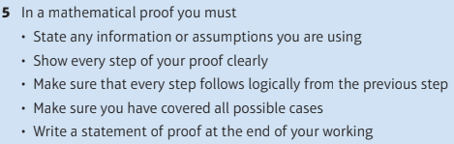
What do you have to end each PROOF question with not (prove question)? | Q.E.D
Define proof by exhaustion | Showing it is true for every possibility
Which numbers are most used to do proof by counter example | -1 to 4 but most likely -1,0,1 or 2  Always worth to do -4 to 4

2 Algebra & functions

2.1 Understand and use the laws of indices for all rational exponents.

[ $a^{m}×a^{n} =a^{m+n}, a^{m}÷a^{n}, (a^{m})^{n}=a^{mn}$ The equivalence of $a^{\frac{m}{n}}$ and $\sqrt[n]{a^{m}}$ should be known.]
What is the equation for the surface area of a sphere using the radius and diameter? | 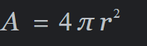  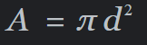
What is the equation for the volume of a sphere using the radius and diameter? | 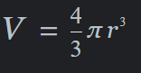  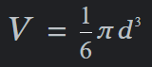
What is the equation for the Volume of a cylinder using radius and diameter? | 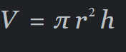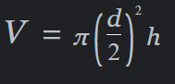
What is the equation for the Surface Area of a cylinder using radius and diameter? | 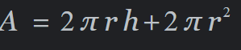  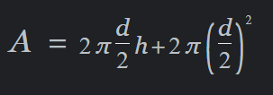
What is the equation for the Circumference of a circle using radius and diameter? | 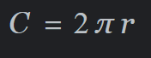  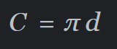

2.2 Use and manipulate surds, including rationalising the denominator.

[ Students should be able to simplify algebraic surds using the results] 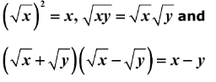

2.3 Work with quadratic functions and their graphs. The discriminant of a quadratic function, including the conditions for real and repeated roots. Completing the square.Solution of quadratic equations including solving quadratic equations in a function of the unknown.

[The notation f(x) may be used Need to know and to use b2 – 4ac > 0, b2 – 4ac = 0 and b2 – 4ac < 0 Solution of quadratic equations by factorisation, use of the formula, use of a calculator or completing the square. These functions could include powers of x, trigonometric functions of x, exponential and logarithmic functions of x.
# Candidates should use the most appropriate method of solving the given quadratic. Questions will be phrased in such a way as to make clear if calculators should not be used. For example: Solve, using algebra and showing each stage of your working, the equation $x-6\sqrt{4}+4=0$. Exponential functions could include examples of the form $4^{x}-7(2^{x})+12=0$#
If b²-4ac > 0 then how many roots are there? | Two distinct real roots
If b²-4ac = 0 then how many roots are there? | One real and equal root
If b²-4ac < 0 then how many roots are there? | No real roots

2.4 Solve simultaneous equations in two variables by elimination and by substitution, including one linear and one quadratic equation.

[This may involve powers of 2 in one unknown or in both unknowns, e.g. solve y = 2x + 3, y = x2 – 4x + 8 or 2x – 3y = 6, x2 – y2 + 3x = 50]

#Students may be required to set up and solve equations within a modelling context.#

2.5 Solve linear and quadratic inequalities in a single variable and interpret such inequalities graphically, including inequalities with brackets and fractions. Express solutions through correct use of ‘and’ and ‘or’, or through set notation. Represent linear and quadratic inequalities such as y > x + 1 and y > ax2 + bx + c graphically.

[e.g. Solving ax + b > cx + d, px2 + qx + r ≥ 0, px2 + qx + r < ax + b and interpreting the third inequality as the range of x for which the curve y = px² + qx + r is below the line with equation y = ax + b

These would be reducible to linear or quadratic inequalities e.g. $\frac{a}{x}$ < b becomes ax < bx²

So, e.g. x < a or x > b is equivalent to { x : x < a } ∪ { x : x > b } and { x : c < x } ∩ { x : x < d } is equivalent to x > c and x < d Shading and use of dotted and solid line convention is required.]
What is the set notation for x < -1 as well as x > 2  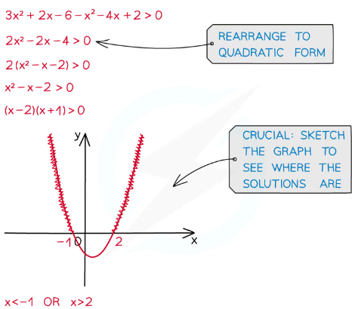 | {x: x<-1 U x>2} or {x: x<-1} ∪ {x: x>2}  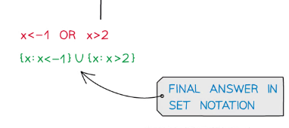
What is the set notation for x > -5 AND x < 5 | {x: x>-5 ∩ x<5} or {x: x>-5} ∩ {x: x<5}

2.6 Manipulate polynomials algebraically, including expanding brackets and collecting like terms, factorisation and simple algebraic division; use of the factor theorem.

[ Only division by (ax + b) or (ax – b) will be required. Students should know that if f(x) = 0 when x =$\frac{b}{a}$, then (ax – b) is a factor of f(x). Students may be required to factorise cubic expressions such as x3 + 3x2 – 4 and 6x3 + 11x2 – x – 6.]

#When factorising cubic expressions, students will be given one factor or enough information to work out one factor.#

2.7 Understand and use graphs of functions; sketch curves defined by simple equations including polynomials $y = \frac{a}{x}$ and $y = \frac{a}{x^{2}}$ (including their vertical and horizontal asymptotes) Interpret algebraic solution of equations graphically; use intersection points of graphs to solve equations. Understand and use proportional relationships and their graphs.

[Graph to include simple cubic and quartic functions, e.g. sketch the graph with equation y = x2(2x – 1)2 The asymptotes will be parallel to the axes e.g. the asymptotes of the curve with equation y = $\frac{2}{x+a}$+ b are the lines with equations y = b and x = − a Express relationship between two variables using proportion “∝” symbol or using equation involving constant e.g. the circumference of a semicircle is directly proportional to its diameter so C ∝ d or C = kd and the graph of C against d is a straight line through the origin with gradient k.]

#Students may be required to sketch the graph of any function defined by the specification, including polynomial, exponential, logarithmic and trigonometric functions,. Where students are required to find the asymptotes of a curve defined by a function that is more complicated than those they are expected to sketch, the graph will be provided.#
Draw a reciprocal graph of y=1/x | 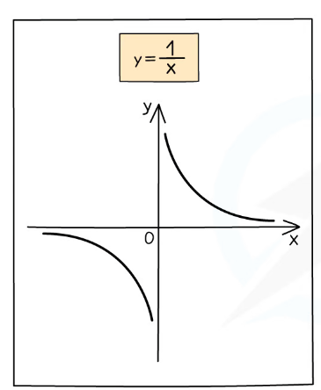
Draw a reciprocal graph of y=1/x^2 | 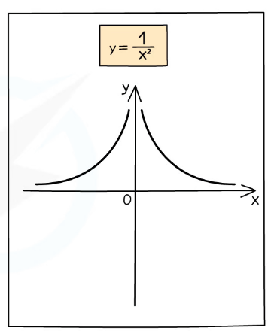
Draw a reciprocal graph of y=-1/x^2? | 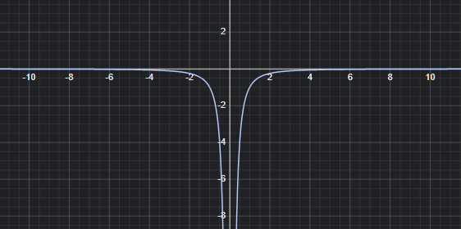
Draw a reciprocal graph of y=-1/x | 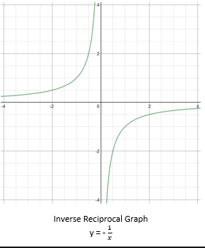
Draw a positive quartic graph? | 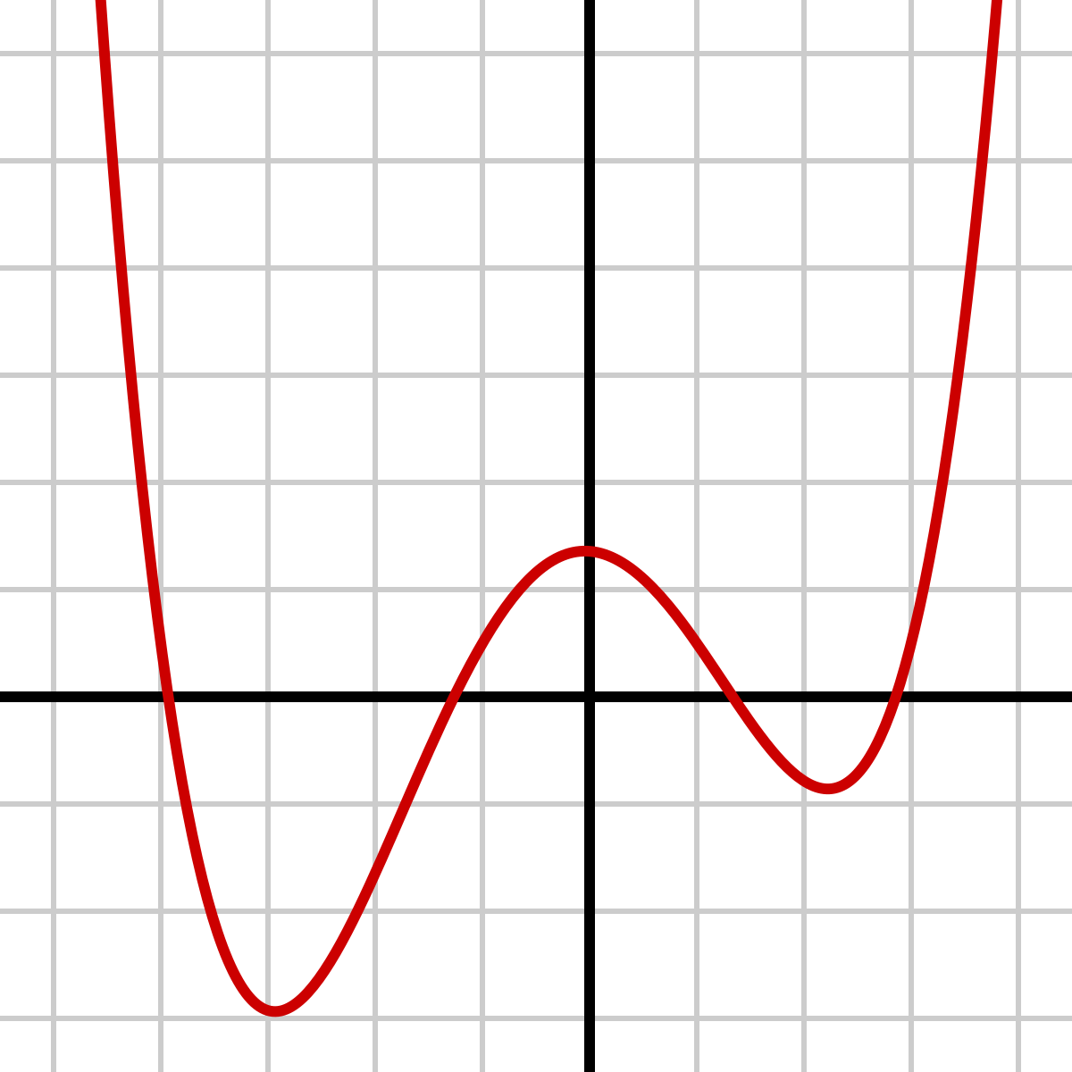
Draw a negative quartic graph? | 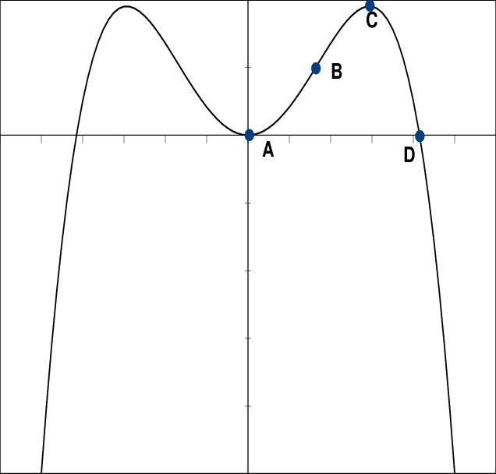

2.9 Understand the effect of simple transformations on the graph of y = f(x), including sketching associated graphs: y = af(x), y = f(x) + a, y = f(x + a), y = f(ax)
What does a stretch of y=af(x) do (x coordinates stay the same? | Vertical stretch by scale factor of a on the x axis
What does a stretch of y=f(ax) do (y coordinates stay the same) | Horizontal stretch by scale factor of 1/a on the y axis
What does a translation of y=f(x)+a do? | Vertical translation along the y axis
What does a translation of y=f(x+a) do? | Horizontal translation along the x axis
What does a reflection of y=-f(x) do? | Reflection in the x axis
What does a reflection of y=f(-x) do? | Reflection in the y axis

3 Coordinate geometry in the (x,y) plane

3.1 Understand and use the equation of a straight line, including the forms y – y₁ = m(x – x₁) and ax + by + c = 0; Gradient conditions for two straight lines to be parallel or perpendicular. Be able to use straight line models in a variety of contexts.

[To include the equation of a line through two given points, and the equation of a line parallel (or perpendicular) to a given line through a given point. m′ = m for parallel lines and m′ = $-\frac{1}{m}$ for perpendicular lines. For example, the line for converting degrees Celsius to degrees Fahrenheit, distance against time for constant speed, etc.]
What is the equation for a straight line (not y=mx+c) and in its 2 arrangements? | y - y₁ = m (x - x₁) and m= y₂ - y₁ / x₂ - x₁  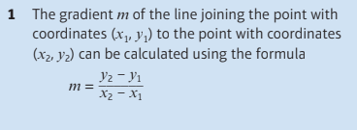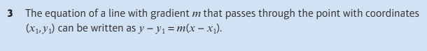
What is the gradient of a line perpendicular (or perpendicular bisector) to another one with m representing the gradient? | -1/m the negative reciprocal  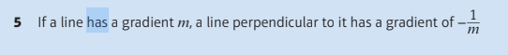
What is the equation to find the midpoint of a straight line? | ( (x₁ + x₂ / 2),(y₁ + y₂/ 2) )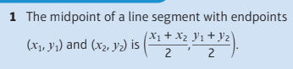
What is the equation of a circle? | (x-a)² + (y-b)² = r²
What is the equation to find the length of one side of a triangle of a circumcircle? | d = √(x₂ - x₁)² + (y₂ - y₁ )²

3.2 Understand and use the coordinate geometry of the circle including using the equation of a circle in the form (x – a) 2 + (y – b) 2 = r2 Completing the square to find the centre and radius of a circle; use of the following properties:● the angle in a semicircle is a right angle ● the perpendicular from the centre to a chord bisects the chord ● the radius of a circle at a given point on its circumference is perpendicular to the tangent to the circle at that point.

[Students should be able to find the radius and the coordinates of the centre of the circle given the equation of the circle, and vice versa. Students should also be familiar with the equation x² + y² + 2fx + 2gy + c = 0 Students should be able to find the equation of a circumcircle of a triangle with given vertices using these properties. Students should be able to find the equation of a tangent at a specified point, using the perpendicular property of tangent and radius.]

4 Sequences and series

4.1 Understand and use the binomial expansion of (a + bx)^{n} for positive integer n; the notations n! and $n⊂r$ link to binomial probabilities.

[Use of Pascal’s triangle. Relation between binomial coefficients.Also be aware of alternative notations such as $(\frac{n}{r})$ and $n⊂r$ Considered further in Paper 3 Section 4.1]
What are the steps in finding the approximate value for a term using binomial expansion?  If given (1-x)^½ as the binomial  And 0.96^½ as the term to approximate?  And the first 3 terms are 1 - ½ (x) - ⅛ (x)^2 | 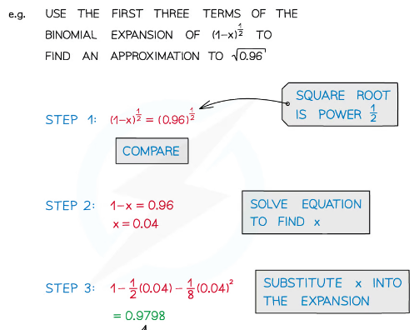  - Compare and equate (1-x)^½ = (0.96)^{½}  - Solve to find x by dividing powers on both sides and extra 1-x = 0.96 -> x = 0.04  - Subsitute this value of x into the expansion and find approximation 1-½(0.04) - ⅛(0.04)²  - Equals 0.09798
What notation should ALWAYS be used when doing binomial expansion  e.g., what is the first 3 terms of (1-x)^½? | (1-x)^½ = 1 -1/2x -1/8x^2 - 1/16x^3 - …  Remember the Elipsis!  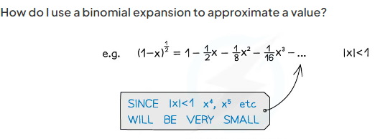

5 Trigonometry

5.1 Understand and use the definitions of sine, cosine and tangent for all arguments; the sine and cosine rules; the area of a triangle in the form 0.5xaxbxsinC

[Use of x and y coordinates of points on the unit circle to give cosine and sine respectively, including the ambiguous case of the sine rule.]
What should you do to check if a sine rule question in an ambiguous case? | Check if the angle we are calculating using the sine rule is acute or obtuse

5.3 Understand and use the sine, cosine and tangent functions; their graphs, symmetries and periodicity.

[Knowledge of graphs of curves with equations such as y = sin x, y = cos(x + 30°), y = tan 2x is expected.]

5.5 Understand and use $tanΘ=\frac{sinΘ}{cosθ}$ Understand and use$sin^{2}θ+cos^{2}θ = 1$

[These identities may be used to solve trigonometric equations and angles may be in degrees or radians. They may also be used to prove further identities.]

5.7 Solve simple trigonometric equations in a given interval, including quadratic equations in sin, cos and tan and equations involving multiples of the unknown angle.

[Students should be able to solve equations such as $sin (x + 7{0^{∘})=0.5 for 0<x< 360^{∘}, 3 + 5 cos2x = }_{}$

$= 1 for-180^{∘}<x< 180^{∘} 6 cos^{2}x +sinx-5=0,0<=x<360^{∘}$]

6 Exponentials & Logarithms

6.1 Know and use the function a^{x} and its graph, where a is positive.Know and use the function e^{x} and its graph.

[Understand the difference in shape between a < 1 and a > 1]
Draw an exponential graph y=e^x | 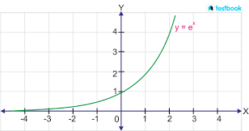
Draw an exponential graph y=e^-x | 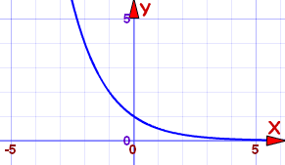

6.2 Know that the gradient of e^{kx} is equal to ke^{kx} and hence understand why the exponential model is suitable in many applications.

[Realise that when the rate of change is proportional to the y value, an exponential model should be used.]
What is the differentiation by first derivative of y=e^{kx} | dy/dx = ke^{kx}
What is the differentiation by first derivative of y=e^{-kx} | dy/dx = -ke^{-kx}

6.3 Know and use the definition of log_{a}x as the inverse of a^{x}, where a is positive and x >= 0. Know and use the function ln x and its graph. Know and use ln x as the inverse function of e^{x} [a ≠ 1 Solution of equations of the form e^{ax + b} = p and ln (ax + b) = q is expected.]

6.4 Understand and use the laws of logarithms: log_{a}x + log_{a}y = log_{a} (xy), log_{a} x − log_{a} y = log_{a}$\left(\frac{x}{y}\right)$, k log_{a} x = log_{a} x^{k} (including, for example, k = −1 and k = –0.5) [Including log_{a}a = 1 ]
What is the multiplication law | Loga x + loga y = loga xy
What is the addition law
What is the division law | Loga x - loga y = loga x/y
What is the subtraction law
What is the power law | Loga x^{k} = kloga x

6.5 Solve equations of the form a x = b

[Students may use the change of base formula. Questions may be of the form, e.g. 2^{3x – 1} = 3]

6.6 Use logarithmic graphs to estimate parameters in relationships of the form y = ax^{n} and y = kb^{x} , given data for x and y

[Plot log y against log x and obtain a straight line where the intercept is log a and the gradient is n, Plot log y against x and obtain a straight line where the intercept is log k and the gradient is log b]

6.7 Understand and use exponential growth and decay; use in modelling (examples may include the use of e in continuous compound interest, radioactive decay, drug concentration decay, exponential growth as a model for population growth); consideration of limitations and refinements of exponential models.

[Students may be asked to find the constants used in a model. They need to be familiar with terms such as initial, meaning when t = 0. They may need to explore the behaviour for large values of t or to consider whether the range of values predicted is appropriate. Consideration of an improved model may be required.]

#Students may be asked to explain how a given model could be improved to better fit the situation.#

7 Differentiation

7.1 Understand and use the derivative of f(x) as the gradient of the tangent to the graph of y = f(x) at a general point (x, y); the gradient of the tangent as a limit; interpretation as a rate of change sketching the gradient function for a given curve. Second derivatives. Differentiation from first principles for small positive integer powers of x Understand and use the second derivative as the rate of change of gradient;

[Know that $\frac{dy}{dx}$is the rate of change of y with respect to x. The notation f′(x) may be used for the first derivative and f ′′(x) may be used for the second derivative. Given for example the graph of y = f (x), sketch the graph of y = f ′(x) using given axes and scale. This could relate speed and acceleration for example. For example, students should be able to use, for n = 2 and n = 3, the gradient expression $\lim_{h→0}\left(\frac{(x+h)^{n}-x^{n}}{h}\right)$.Students may use δx or h. Use the condition f ′′(x) > 0 implies a minimum and f ′′(x) < 0 implies a maximum for points where f′(x) = 0]

# Variables other than x may be used.#
Differentiate f(x) or y = 4x^3 + 3x^2 + 2x + 3 by 2nd derivatives? | f’(x) or dy/dx = 4/3x^2 + 3/2x + 2  f’’(x) or d^2y/dx^2 = 4/6x + 3/2
When dealing with a turning point if  dy/dx = 0 (@Tp) &  dx^2/ d^2y > 0  is the point a local minimum or maximum? | Local minimum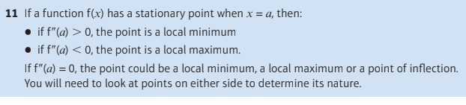
When dealing with a turning point if  dy/dx = 0 (@Tp) &  dx^2/ d^2y < 0  is the point a local minimum or maximum? | Local maximum
What is the differentiation by first derivative of y=e^{kx} | dy/dx = ke^{kx}
What is the differentiation by first derivative of y=e^{-kx} | dy/dx = -ke^{-kx}
Differentiate f(x) or y = 2x^3+4x^2+3x+1 by 1st derivatives? | f’(x) or dy/dx = 2/3x^2 + 2x + 3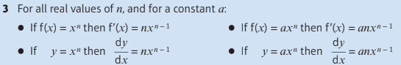
What is the differentiation by the first principle equation? | 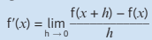  REMEMBER THE MINUS in (f(x+h) - f(x) ) AND if f(x) = 3x^2 it would be 3(x+h)^2 not (3x+h)^2 due to BIDMAS
Differentiate f(x) = 3 by first derivatives? | f’(x) = 0
Differentiate f(x) = -5x by first derivatives? | f’(x) = -5
Differentiate y = sqrt 7 by first derivatives? | dy/dx = 0
Differentiate y = x by first derivatives? | dy/dx = 1

7.2 Differentiate x^{n}, for rational values of n, and related constant multiples, sums and differences.

[For example, the ability to differentiate expressions such as (2x + 5)(x – 1) and $\frac{x^{2}+4x-5}{4x^{\frac{1}{2}}}$, x > 0, is expected.

7.3 Apply differentiation to find gradients, tangents and normals maxima and minima and stationary points. Identify where functions are increasing or decreasing.

[Use of differentiation to find equations of tangents and normals at specific points on a curve. To include applications to curve sketching. Maxima and minima problems may be set in the context of a practical problem. To include applications to curve sketching.]

# A function is increasing on a given interval if f ' (x) > 0 (or f '(x) ≥ 0) for all values of x in that interval. A function is decreasing on a given interval if f '(x) < 0 (or f ' (x) ≤ 0) for all values of x in that interval.#
What should be done if dx^2/d^2y = 0 as this could be a local maximum, minimum or point of interflection?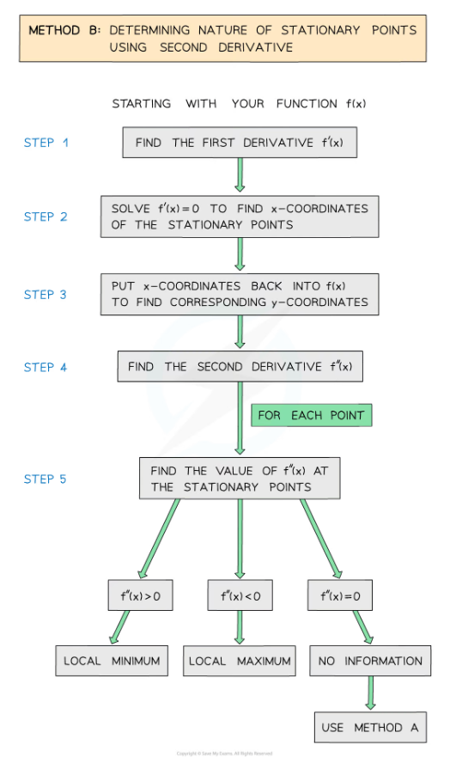 | Then for each x coordinate take a value between 0 and +1 (of the original x value) and another between 0 and -1 (of the original x value) and sub it into dy/dx or f’(x).  If the x value is negative to the left and positive to the right then its a local minimum  If the x value is positive to the left and negative to the right then its a local maximum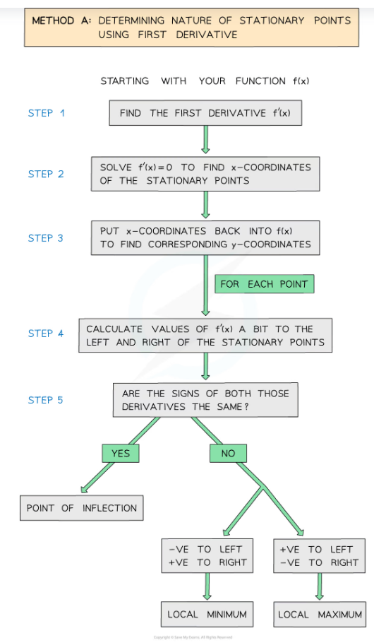

8 Integration

8.1 Know and use the Fundamental Theorem of Calculus [Integration as the reverse process of differentiation. Students should know that for indefinite integrals a constant of integration is required.]
If dy/dx or f’(x) = 1/4x^2 +4x + 6 what is the indefinite integration of this? And what should be remembered? | ∫(fx)dx = 1/12x^3 + 2x^2 + 6x + C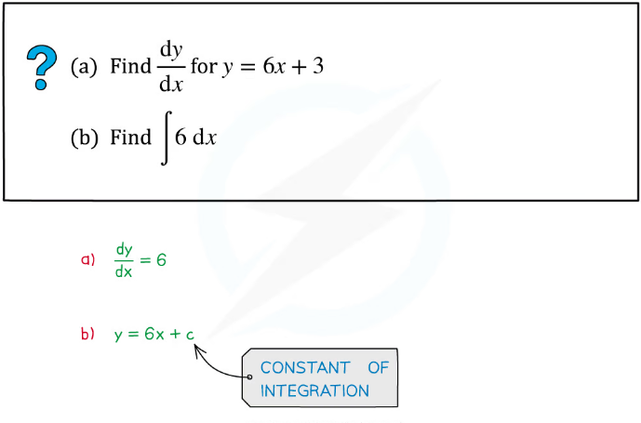
Equation for remembering to put end equation | 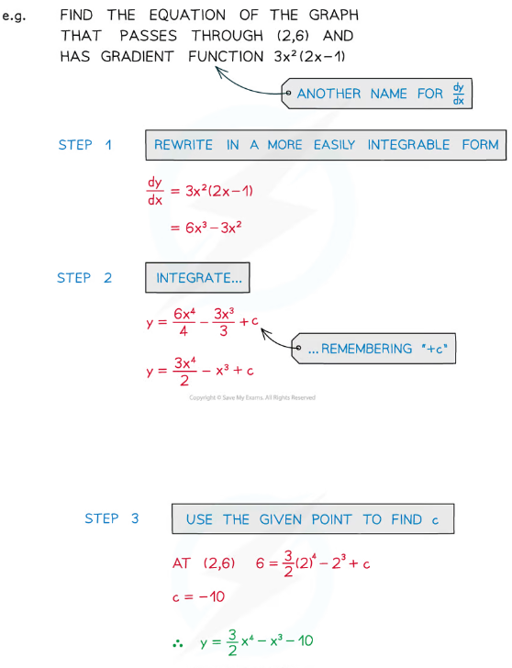

8.2 Integrate x^{n} (excluding n = −1) and related sums, differences and constant multiples.

[For example, the ability to integrate expressions such as $\frac{1}{2}x^{2}-3x^{-\frac{1}{2}}$ and $\frac{(x+2)^{2}}{x^{\frac{1}{2}}}$ is expected. Given f ′(x) and a point on the curve, students should be able to find an equation of the curve in the form y = f (x).]

8.3 Evaluate definite integrals; use a definite integral to find the area under a curve

[Students will be expected to be able to evaluate the area of a region bounded by a curve and given straight lines,For example, find the finite area bounded by the curve y = 6x – x2 and the line y = 2x]

#This may include the example of finding the area between a curve and a given straight line.#

10 Vectors

10.1 Use vectors in two dimensions

[Students should be familiar with column vectors and with the use of i and j unit vectors in two dimensions]

# Questions may be set in two dimensions#

10.2 Calculate the magnitude and direction of a vector and convert between component form and magnitude/direction form.

[Students should be able to find a unit vector in the direction of a, and be familiar with the notation $\left|a\right|$.]

# Questions may be set in two dimensions#

10.3 Add vectors diagrammatically and perform the algebraic operations of vector addition and multiplication by scalars, and understand their geometrical interpretations.

[The triangle and parallelogram laws of addition. Parallel vectors.]

# Questions may be set in two dimensions#

10.4 Understand and use position vectors; calculate the distance between two points represented by position vectors. [OB-> - OA-> = AB-> = b-a

[The distance d between two points(x1 , y1) and (x2 , y2) is given by $d^{2}=(x_{1}-x_{2})^{2}+ (y_{1}-y_{2})^{2}$]

# Questions may be set in two dimensions#

10.5 Use vectors to solve problems in pure mathematics and in context (including forces).

[For example, finding position vector of the fourth corner of a shape (e.g. parallelogram) ABCD with three given position vectors for the corners A, B and C. Contexts such as velocity, displacement, kinematics and forces will be covered in Paper 3, Sections 6.1, 7.3 and 8.1 – 8.4]

#Questions may be set in two dimensions#

